4.Write aphyton program to solve vaccum cleaner problem

Aim:
To write a phyton program to solve vaccum cleaner problem .

Objectives
The objective of the Vacuum Cleaner Problem is to design an intelligent agent that can sense whether a location is clean or dirty and perform the appropriate action to clean it. The agent uses actions such as Suck, Move Left, and Move Right to clean all dirty locations efficiently. The main goal is to ensure that the entire environment becomes clean using the minimum number of actions.

Algorithm :
1. Start.
2. Place the vacuum cleaner at the initial location (A or B).
3. Check whether the current location is Dirty or Clean.
4. If the location is Dirty, perform the Suck operation.
5. Move to the other location.
6. Check whether the new location is Dirty or Clean.
7. If the location is Dirty, perform the Suck operation.
8. Repeat until both locations are Clean.
9. Stop.

Flow chart :

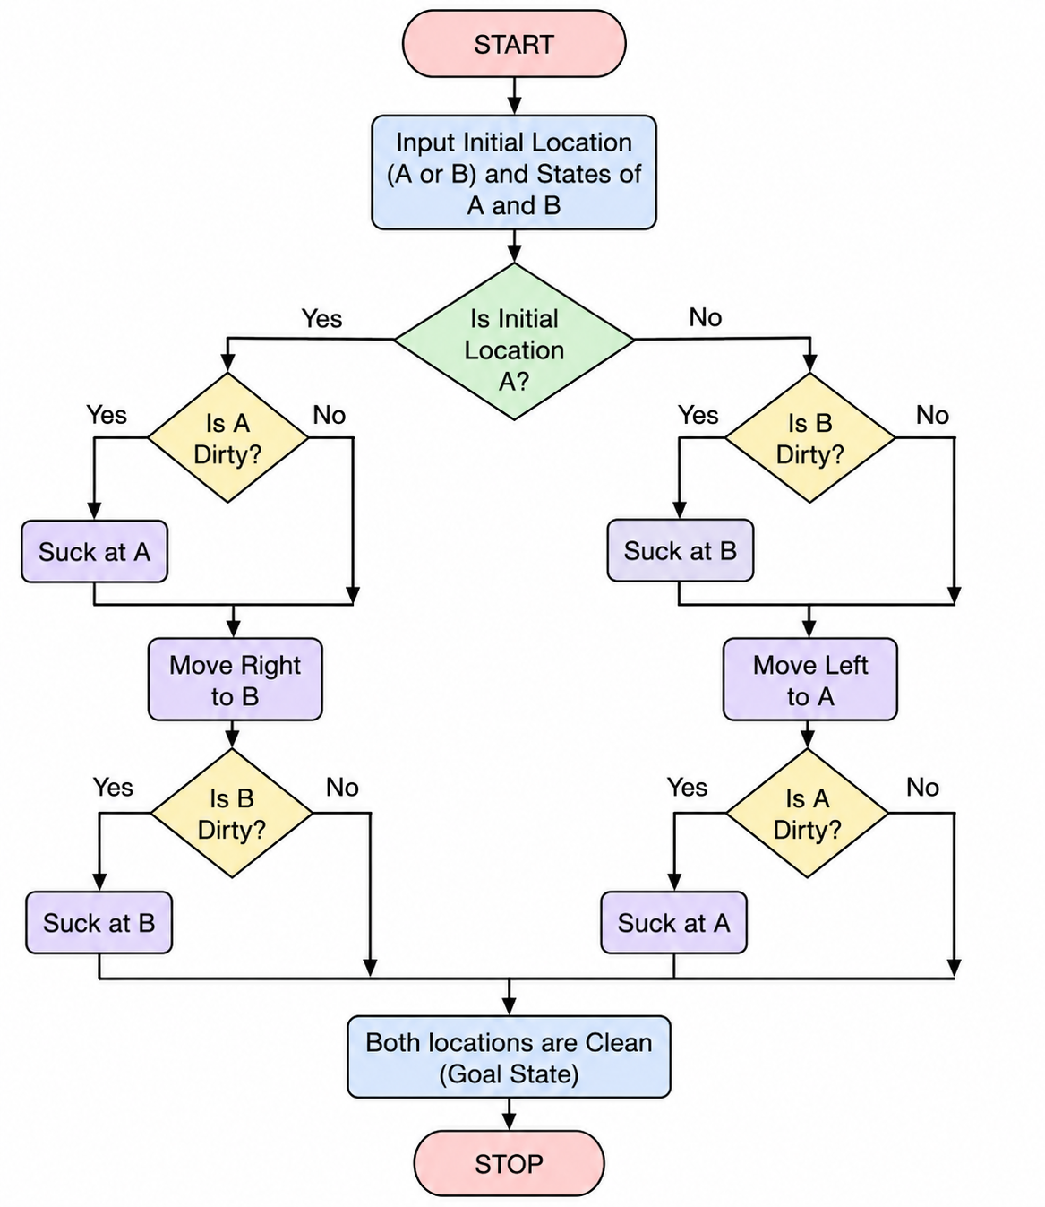
Source Code :

location = input().upper()
A = input().capitalize()
B = input().capitalize()

if location == "A":
if A == "Dirty":
A = "Clean"
print("Suck")
print("Right")
if B == "Dirty":
B = "Clean"
print("Suck")

elif location == "B":
if B == "Dirty":
B = "Clean"
print("Suck")
print("Left")
if A == "Dirty":
A = "Clean"
print("Suck")

print(A)
print(B)

Result :
The Vacuum Cleaner Problem was successfully implemented. The vacuum cleaner agent cleaned all dirty locations and reached the goal state where both locations are clean.

Output :
